**Project Design Phase-II**

**Data Flow Diagram & User Stories**

|  |  |
| --- | --- |
| Date | 03 October 2022 |
| Team ID | PNT2022TMID17878 |
| Project Name | Exploratory Analysis Of Rainfall Data In India For Agriculture |
| Maximum Marks | 4 Marks |

**Data Flow Diagrams:**

A Data Flow Diagram (DFD) is a traditional visual representation of the information flows within a system. A neat and clear DFD can depict the right amount of the system requirement graphically. It shows how data enters and leaves the system, what changes the information, and where data is stored.

**USER CLOUD**

** ** 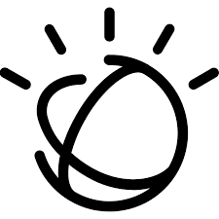 

ML model

IBM Cloud

1. User enters the region into the web application to predict the rainfall rate
2. The input data is sent to the cloud
3. The Machine learning model deployed in the cloud predicts the rainfall
4. And finally the predicted rainfall rate in mm and crops are suggested as output.

**User Stories**

Use the below template to list all the user stories for the product.

|  |  |  |  |  |  |  |
| --- | --- | --- | --- | --- | --- | --- |
| **User Type** | **Functional Requirement (Epic)** | **User Story Number** | **User Story / Task** | **Acceptance criteria** | **Priority** | **Release** |
| Customer (web user) | Check Weather | USN-1 | As a customer, I can check the rainfall by giving the region as input. | I can view the predicted rainfall status by entering information | High | Sprint-2 |
|  | Suggested Crop | USN-2 | As a customer, With the predicted rainfall I can view the suggested crops for higher productivity | I can view the suggested crops with the predicted rainfall | High | Sprint-2 |